Career Information Post

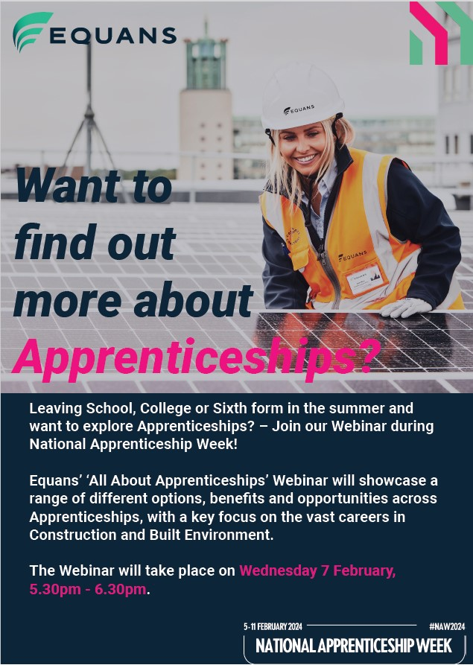

Participants will have the opportunity to ask questions and register their interest for Apprenticeships with Equans.

Wednesday 7th February 2024
17:30pm – 18:30pm
Via TEAMS

To register a place on the webinar, please use this LINK.

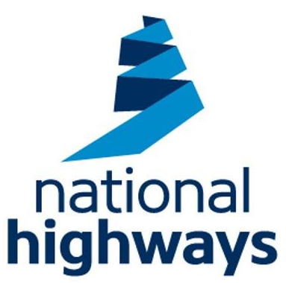

In National Apprenticeship Week National Highways are hosting three webinars:
- Who are National Highways?
- Our apprenticeships and what it means to do an apprenticeship with us- what are we offering and what are the misconceptions.
- Our employee networks and how our apprentices can get involved.
Hear from some of our current apprentices about their experience and how an apprenticeship has equipped them with skills for life!
We will finish off with a Q&A from our Recruitment and Talent specialists!

Find the link to registration and our careers page here where all our vacancies will also be going live on Monday 5th February.





NCD apprenticeship vacancies update
Check out our latest apprenticeship vacancies below - please share the amazing opportunities at NCD with your students so they can discover how they can get a head start in a wide range of sectors with practical experience with a real employer.

Apprentices also earn while they learn, and gain a nationally recognised qualification.

Feel free to get in touch with our Apprenticeships team if you have any questions.

GET IN TOUCH WITH ANY QUESTIONS

Business Admin Apprenticeship

Childcare Apprenticeship

Business Admin Apprenticeship

Teaching Assistant Apprenticeship

Early Years Apprentice

Just a reminder that NCD’s next Information and Advice Event is Tuesday 6th February , 4.30 - 6.30pm.

This a great opportunity for students to visit NCD’s campus, take a tour of their facilities and have a chat with the curriculum and support staff.

The event is also an Apprenticeship Special, with the opportunity to meet their Apprenticeship Team and engage with employers.

There will be a dedicated Apprenticeship space, but all areas will be available.

Future Darlington College Open Events
Open Event – Thursday 21 March 2024 – 5.30PM-7.30PM
Open Event – Monday 29 April 2024 -4PM-6.30PM
Open Event – Monday 24 June 2024 3.30pm – 6.30PM

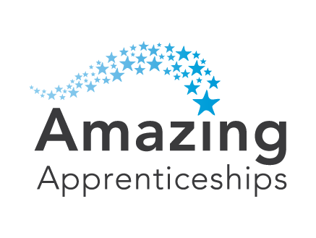

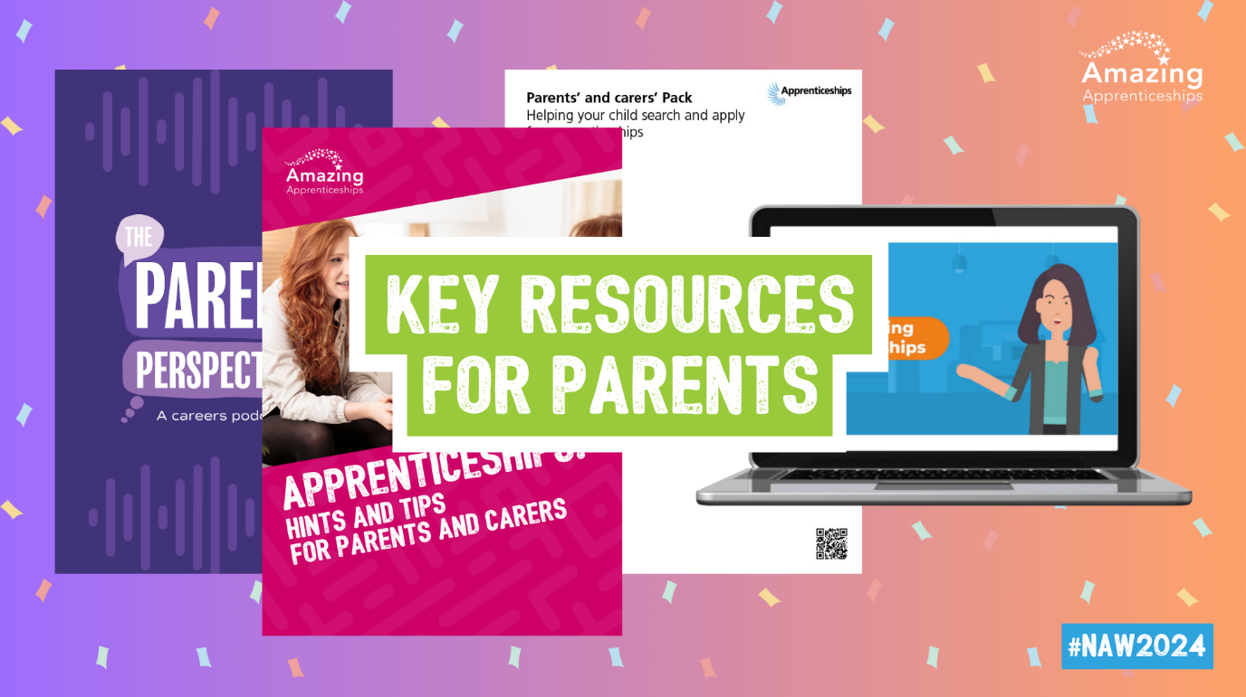

4 Ways to Get Parents Involved
in NAW2024!

We've highlighted 4 ways you can get parents and carers involved and informed this National Apprenticeship Week.

There's something for everyone,
with resources to watch, listen, read and do!

Read on below for a run-down of everything...

Resources you can download now...

  
  WATCH
  Understanding Apprenticeships animated film answers some of the key questions around apprenticeships and covers what to expect, the benefits of apprenticeships and the range of opportunities available.
  WATCH THE FILM

  
  LISTEN
  The Parents Perspective Podcast, hosted by Rachel Burden, is an engaging podcast series for parents and carers, helping them to support their children with careers advice and guidance from a variety of expert speakers.
  LISTEN NOW

  
  READ
  The Parents & Carers Pack is a monthly magazine containing the latest apprenticeship information, advice and case studies for parents and carers, supported by the Education and Skills Funding Agency.
  READ THE LATEST PACK

  
  DO
  The Parents' Guide to Apprenticeships helps parents and carers to explore the world of apprenticeships with their child, understand the range of resources and support services available to them, and how to access them.
  DOWNLOAD THE GUIDE

Get social with us!

Follow us on our social media channels to keep up to date with newly released resources, news, events and more - simply click on the social buttons below!

  
  
  
  

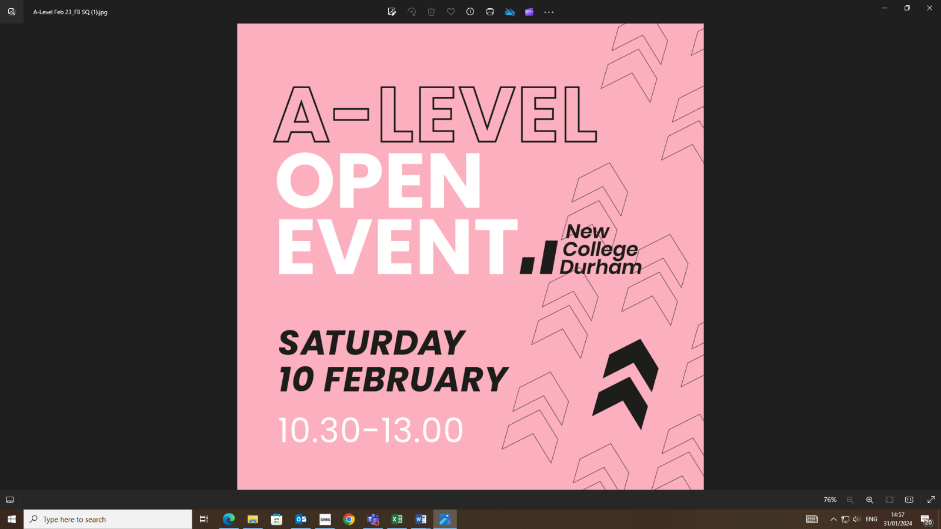

Interested in an Apprenticeship in the NHS?
Click here for more information.
You can also find a YouTube video on NHS Apprenticeships here
You can search for jobs in the NHS here

Want to know more about T-Levels?
Watch the T-Level explainer film where the key facts about T Levels are explained by students, teachers and employers.
Click here to access the film.

SKILLS CHECKER
Take a 5 to 10 minute assessment to find out what job categories, and which particular job roles, might suit you. You don’t need to sign in or create an account to save your assessment. You can also complete it later and look at your results again at any time.
Go to the National Careers Service website

Looking for a job after leaving school?
www.indeed.co.uk - live vacancies, recruitment support and CV matching service.
www.fish4jobs.co.uk - live vacancies, recruitment support and CV matching service.
www.jobsite.co.uk - live vacancies, recruitment support and CV matching service.

Want to know more about careers in the construction industry?
Go Construct showcases the many career opportunities available in construction and the built environment. https://www.goconstruct.org/

Careers in Sport
The latest news, jobs and careers advice in the Sports Industry. https://careers-in-sport.co.uk/

Career Pilot – Information on Post 16 Choices
https://www.careerpilot.org.uk/information/your-choices-at-16/help-with-choosing-your-post-16-options

Use the Government's 'Find a Job' service to search and apply for jobs on their website. Click here to go to their website.

Durham Works:
Wondering what to do next? DurhamWorks can work with you to explore employment, education and training. You can talk to one of our advisors on our online chat facility about your future career visit www.durhamworks.info and look for the green icon on right hand side, call us on 03000 262 930 or contact us via the website https://durhamworks.info/your-future/get-started

Twitter @WorksDurham
Instagram: durham_works
LinkedIn: DurhamWorks
Facebook: facebook.com/DurhamWorks
Website: www.durhamworks.info

Explore Careers on the World Skills Website: Browse over 40 different career routes across multiple sectors
https://www.worldskillsuk.org/careers-advice/?utm_source=Partner&utm_medium=Careers_Week&utm_campaign=Skills_Days

Explore Success at School’s Career Zones to find out all about the different jobs you can do, what to study and how to get there, whether you're planning to leave school or heading to college or uni. Each career zone has helpful interviews, advice and links to set you on the right path to career superstardom.
https://successatschool.org/careerzones

National Careers Service - here is a link to the National Careers Service website which is also on the careers section of the school’s website. Use the skills assessment on their site to identify some career ideas and then use the “Explore Careers” section for more information.
The National Careers Service is also available to offer support with careers, jobs and learning over the phone, online and through social media. If you, or someone you know needs support, get in touch on 0800 100 900 or find them online.

Not sure what careers is right for you? Research careers below:
http://www.careersbox.co.uk/

BBC Bitesize Careers
Whether you’re deciding what to study, taking your exams, planning a career, or just curious, we’re here to explain the world of work, with advice from people who've found the right path for them, visit the BBC Bitesize Careers website. Careers - BBC Bitesize

Army Careers
Interested in a career in the Army? More details here

Electrical Careers Website
A careers website from The Electrotechnical Skills Partnership (TESP) which contains lots of useful information including routes into the industry. Click on the heading above to find out more.

North East Opportunities Website
North East Opportunities is a website where you can search for available jobs across the North East and explore different career areas. It also has up to date Labour Market Information on what industries currently have the highest number of vacancies in the North East. You can access the website through this link.

Staindrop’s Post 16 Providers Page
Wondering where to go after Y11? Check out our Post 16 Providers page here
We also have a page on our website dedicated to careers. This can be found here
Got a question about careers or do you need help applying to a Sixth Form, College or Apprenticeship? If so you can contact Mr Marwood at p.marwood@staindropschool.com.
You can also use some of the links in the careers section of our website. You can access this by clicking here.



